

Final Year Project Report

**PakWork**

Project Team:

Asaad Noman Abbasi (1912297)

Muhmmad Ahsan (1912310)

Project Supervisor:

Muhammad Shahzad Haroon

Date: 9th November 2022

Submitted in partial fulfillment of the requirements for the degree of

Bachelor of Science in Computer Science

in the

Faculty of Computing and Engineering Sciences

Shaheed Zulfikar Ali Bhutto Institute of Science and Technology

(SZABIST)

Karachi Campus

**Declaration of Authorship**

We, Asaad Noman (1912297) and Muhammad Ahsan (1912310), declare that this report titled, “PakWork” and the work presented in it are our own. We confirm that: This work was done wholly or mainly while in candidature for a bachelor’s degree at this University. Where any part of this report has previously been submitted for a degree or any other qualification at this University or any other institution, this has been clearly stated. Where we have consulted the published work of others, this is always clearly attributed. Where we have quoted from the work of others, the source is always given. With the exception of such quotations, this report is entirely our own work. We have acknowledged all main sources of help. Where the report is based on work done by us jointly with others, we have made clear exactly what was done by others and what we have contributed ourselves.

Signed: Asaad Noman (1912297), Muhammad Ahsan (1912310)

Date: 9th November, 2022

**Acknowledgment**

In the name of ALLAH, the most beneficent and merciful who gave us the knowledge and courage to work on this research area. The success and final outcome of this project required a lot of guidance and assistance from many people and we are extremely privileged to have got this all along the completion of our project. We would first like to thank our supervisor “Sir Shahzad Haroon” of the Computer Science faculty at Shaheed Zulfiqar Ali Bhutto Institute of Science and Technology. The door to his office was always open whenever we ran into a trouble spot or had a question about our project or documentation. He consistently helped, cooperated and motivated us throughout the research. We would like to thank to our teachers who guided us in the light of their knowledge and experience. We would also like to express our gratitude to our loving parents and family members who helped and gave us encouragement. Furthermore, we would also like to acknowledge with much appreciation the crucial role of the staff of SZABIST, who gave the permission to use all required equipment and the necessary materials to complete the project. At the end, we would like to thank Shaheed Zulfiqar Ali Bhutto Institute of Science and Technology for providing us such an inspiring environment. The quality education, the cooperative faculty members and the challenging environment have always motivated and boosted the confidence level of each and every student who has been a part of Shaheed Zulfiqar Ali Bhutto Institute of Science and Technology. And many thanks to all those who let us share their knowledge and resources.

Table of Contents

Table of Contents 4

Revision History 5

Iteration Plan 6

FYP Project Proposal 9

1. Introduction 10

2. Objective 10

3. Problem Description 10

4. Methodology 10

5. Project Scope 11

6. Feasibility Study 11

7. Solution Application Areas 11

8. Tools/Technology 11

9. Expertise of the Team Members 12

10. Milestones 12

11. Project Schedule 13

12. Work Breakdown Structure 13

13. References 18

Software Requirements Specification 19

1. Introduction 20

1.1 Purpose 20

1.2 Document Conventions 20

1.3 Intended Audience and Reading Suggestions 20

1.4 Product Scope 20

1.5 References 20

2. Overall Description 20

2.1 Product Perspective 20

2.2 Product Functions 21

2.3 User Classes and Characteristics 21

2.4 Operating Environment 22

2.5 Design and Implementation Constraints 22

2.6 User Documentation 22

2.7 Assumptions and Dependencies 22

3. External Interface Requirements 22

3.1 User Interfaces 22

3.2 Hardware Interfaces 26

3.3 Software Interfaces 26

3.4 Communications Interfaces 26

4. System Features 26

4.1 Freelancer Registration / Verification System 27

4.2 Gig / Job Creating & Posting 29

4.3 Profile Dashboard 31

4.4 Search System 33

4.5 Buyer Requests 35

4.6 Order Management 36

4.7 Custom Offers 38

4.8 Bidding System 39

4.9 Push Notification System 40

4.10 Chat System 42

4.11 Rating/Feedback System 43

4.12 Personalized Testing System 44

5. Other Nonfunctional Requirements 46

5.1 Performance Requirements 46

5.2 Safety Requirements 46

5.3 Security Requirements 46

5.4 Software Quality Attributes 46

5.5 Business Rules 46

6. Other Requirements 46

Appendix A: Glossary 47

Appendix B: Analysis Models 47

ERD: 47

System Use Case Diagram: 48

Domain Model: 49

Appendix C: To Be Determined List 50

Testing Documents 51

Diagrams 55

**1. System Sequence Diagrams** 56

1.1. Freelancer Registration / Verification 56

1.2. Gigs / Job Posting 56

1.3.Profile Dashboard 57

1.4.Search System 57

1.5.Buyer Requests 58

1.6.Order Management 58

1.7.Custom Offers 59

1.8.Bidding Sysetm 59

1.9.Push Notification System 60

1.10.Chat System 60

1.11 Rating/Feedback System 61

1.12.Personalized Testing System 61

Revision History

|  |  |  |  |
| --- | --- | --- | --- |
| **Name** | **Date** | **Reason For Changes** | **Version** |
|  |  |  |  |
|  |  |  |  |

# Iteration

# Plan

|  |  |  |  |  |  |
| --- | --- | --- | --- | --- | --- |
| **PakWork Iteration Plan** | | | | | |
|  |  |  |  |  |  |
| **S.No.** | **Features** | **FYP-I Iterations** | | | |
| **Monthly Iteration-I** | **Monthly Iteration-II** | **Monthly Iteration-III** | **Monthly Iteration-IV** |
| F1 | Freelancer Registration & Verification System | Requirements |  |  |  |
| Design |  |  |  |
|  | Implementation |  |  |
|  | Testing |  |  |
| F2 | Client Registration System | Requirements |  |  |  |
| Design |  |  |  |
|  | Implementation |  |  |
|  | Testing |  |  |
| F3 | Profile Dashboard | Requirements |  |  |  |
| Design |  |  |  |
|  | Implementation | Implementation |  |
|  |  | Testing |  |
| F4 | Jobs / Gigs Posting | Requirements |  |  |  |
|  |  | Design |  |
|  |  | Implementation |  |
|  |  |  | Testing |
| F5 | Order Management | Requirements |  |  |  |
|  |  |  |  |
|  |  | Design |  |
|  |  | Implementation | Testing |
| F6 | Buyer Requests | Requirements |  |  |  |
|  |  |  |  |
|  |  | Design |  |
|  |  | Implementation | Testing |
| F7 | Search System | Requirements |  |  |  |
|  |  |  |  |
|  |  | Design |  |
|  |  | Implementation | Testing |
| **S.No.** | **Features** | **FYP-II Iterations** | | | |
| **Monthly Iteration-I** | **Monthly Iteration-II** | **Monthly Iteration-III** | **Monthly Iteration-IV** |
| F8 | Bidding System | Requirements |  |  |  |
| Design |  |  |  |
| Implementation | Implementation |  |  |
|  | Testing |  |  |
| F9 | Push Notifications | Requirements |  |  |  |
| Design |  |  |  |
|  | Implementation |  |  |
|  | Testing |  |  |
| F10 | Custom Offers | Requirements |  |  |  |
| Design |  |  |  |
|  | Implementation |  |  |
|  | Testing |  |  |
| F10 | Chat System | Requirements |  |  |  |
|  | Design | Design |  |
|  |  | Implementation | Implementation |
|  |  |  | Testing |
| F11 | Rating & Feedback System | Requirements |  |  |  |
|  |  | Design |  |
|  |  | Implementation |  |
|  |  |  | Testing |
| F11 | Personalized Testing Systems | Requirements |  |  |  |
|  |  | Design |  |
|  |  | Implementation |  |
|  |  |  | Testing |

# FYP Project Proposal

# Introduction

A Freelancing platform for freelancers. Where freelancers can easily sell their gigs and offer services to potential clients/businesses. We aim to provide a fully featured platform that provides everything necessary for a seamless process of a transaction between two entities.

# 2. Objective

“*To design a platform for freelancers to provide their services to clients*".

# 3. Problem Description

Nowadays, Working remotely seems to be on a much larger scale as many companies whether it be local or offshore are shifting to either hybrid or completely remote-based office environments. This also relates to freelancers, who work remotely with these companies and have tended to rise their numbers. In 2022 it was estimated that 70.4 million freelancers were working around the globe remotely. If we talk about Pakistan, it saw a rise of 48% in the year 2021-2022, ranking it as the 4th most popular country in the freelancing industry globally. There are quite a few benefits of freelancing, such as international remittance coming into local banks via platforms, and the creation of micro-agencies that grow into proper software houses which provide employment opportunities and thus upbringing society. For buyers, it also provides quick and efficient solutions to their problems.

Pakistani freelancers face quite numerous challenges when it comes to freelancing on international platforms, the most common challenge they face is such platforms that provide these services charge quite a handful of service charges for this. Another issue that is often raised by experienced professional freelancers is that clients come with projects that were either unfinished or ruined by unskilled freelancers. Also, the problem of unverified users is on the rise, as on platforms such as Fiverr a single user can create multiple accounts and work, no such identity checks are put into place. Which can lead to fake personas conducting business on the platform. Another issue faced by freelancers is the order policy. Due to some policies regarding order acceptance freelancers face unjustified disputes.

# 4. Methodology

Now to address the ‘*How*’ part of the proposal. To tackle the challenges mentioned above, we aim to create a platform that targets freelancers with much easier policies and regional service charges. On the other hand, to tackle the issue of unprofessional and unskilled freelancers, we aim to provide a customized filtering process to ensure that only professional and skilled freelancers can be allowed to work on the platform. We also provide a customized test related to the job that is being bided by freelancers so that only matched freelancers can bid on outsourced projects by businesses, as this way we can tackle much of the filtering part we can offer to the clients. To tackle the issue of the order policy we will make sure that the freelancer has the choice to accept or decline customer job offers made by the client.

# 5. Project Scope

In the previous para, we talked about all the aspects of the scope of the project we are going to develop and work on. But the scope for this project is much more and some development/design aspects will not be implemented in this due course. Such as

* We are not going to implement a payment holding system. Which is a common feature used by these platforms to cater order claims/disputes.

# 6. Feasibility Study

**Risks Involved**:

* Unverified Freelancer using the platform

To tackle this problem, we will implement a system for the verification of CNIC / other documents for the freelancer

**Resource Requirements**: Cloud databases, Cloud service providers, Hosting servers

# 7. Solution Application Areas

In today’s world, freelancing and remote work is on the rise. Pakistan is one of the top 4 service providers in the industry. Our platform aims to cater to the market of freelancers to connect them to potential international/local clients. International platforms charge hefty service charges. The money they make on the platform they withdraw to their local accounts. They are left with 75% of the money that they potentially make. Our platform aims to provide all the features that a competitive platform offers but with policies, service charges, and features to cater to the regional market.

# 8. Tools/Technology

**Software Tools**

* Visual Studio Code
* GitHub Desktop
* NPM
* MongoDB Compass
* Postman / Thunderclient
* Photoshop
* AdobeXD

**Hardware Tools**

* Laptop / PC
* Internet / WiFi Connection

**Technologies**

* JavaScript
* jQuery
* Node JS
* Express JS
* React JS
* MongoDB
* Firebase
* MySQL
* Socket.IO

# 9. Expertise of the Team Members

**Asaad Noman Abbasi (1912297)**

* **Courses Taken:** Fundamentals of Programming (4 GPA), Object Oriented Programming (4 GPA), Data Structures & Algorithms (3.25 GPA), Database Systems (4 GPA), Software Engineering (3.5 GPA), Web Technologies I (4 GPA), Design & Analysis of Algorithms (3.5 GPA)

**Muhmmad Ahsan (1912310)**

* **Courses Taken:** Fundamentals of Programming (4 GPA), Object Oriented Programming (4 GPA), Data Structures & Algorithms (3.25 GPA), Database Systems (3.5 GPA), Software Engineering (3.25 GPA), Web Technologies I (4 GPA), Design & Analysis of Algorithms (3.25 GPA)

This project is of equal interest to the members as they both have experience in programming a web application and have done internships and taken relevant courses in university prior, in the domain of web development.

# 10. Milestones

1. Freelancer Registration / Verification System
2. Project Creation / Posting
3. Order Management
4. Buyer Requests
5. Search System
6. Profile Dashboard
7. Bidding System
8. Push Notification System
9. Custom Offers
10. Chat System
11. Rating/Feedback Systems
12. Personalized Testing System

# 11. Project Schedule

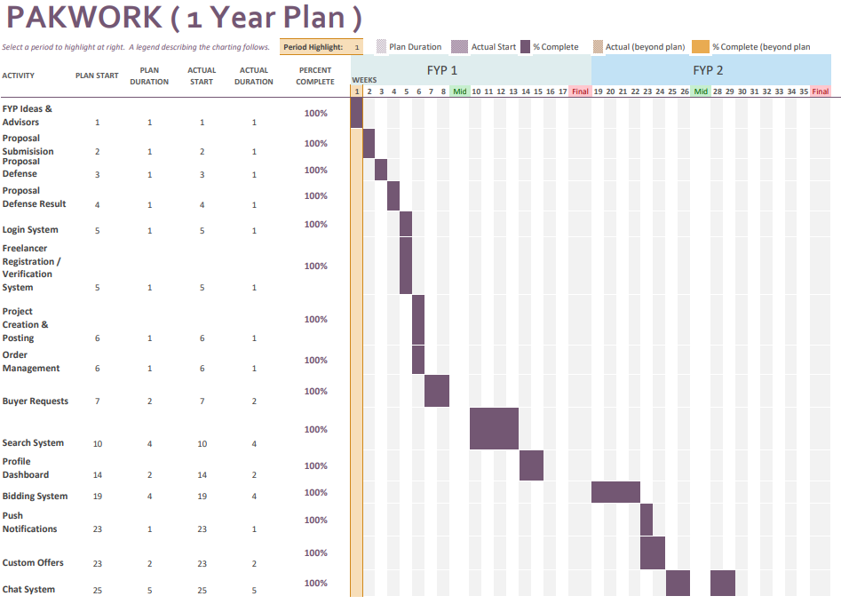

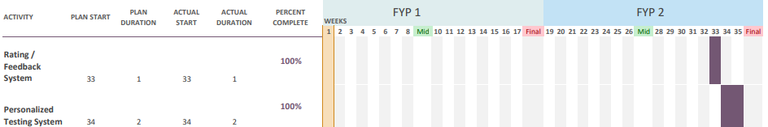

# 12. Work Breakdown Structure

**WBS & Gantt Chart (FYP 1) (Fall)**

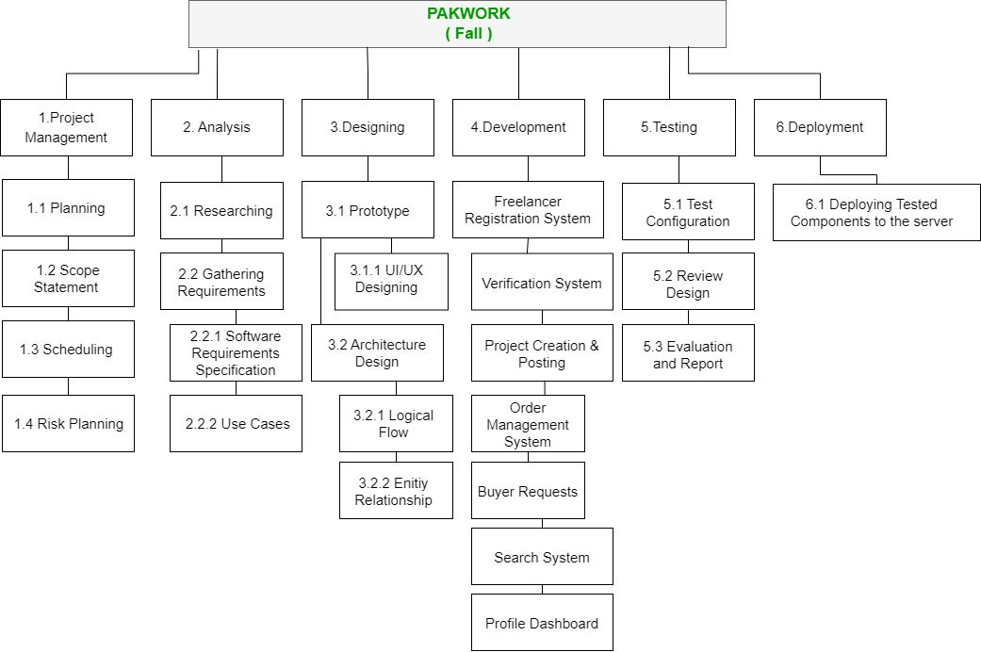

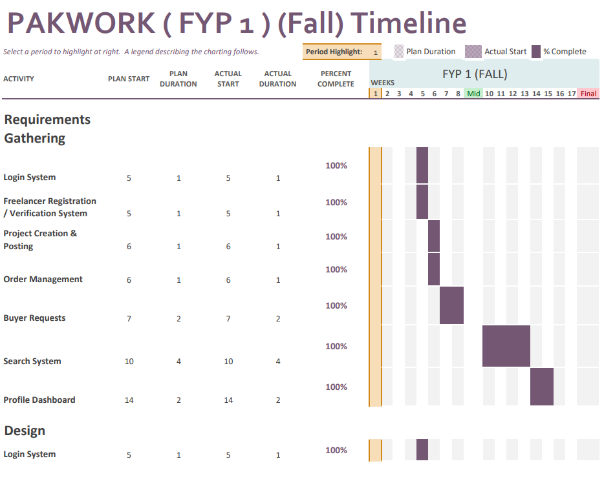

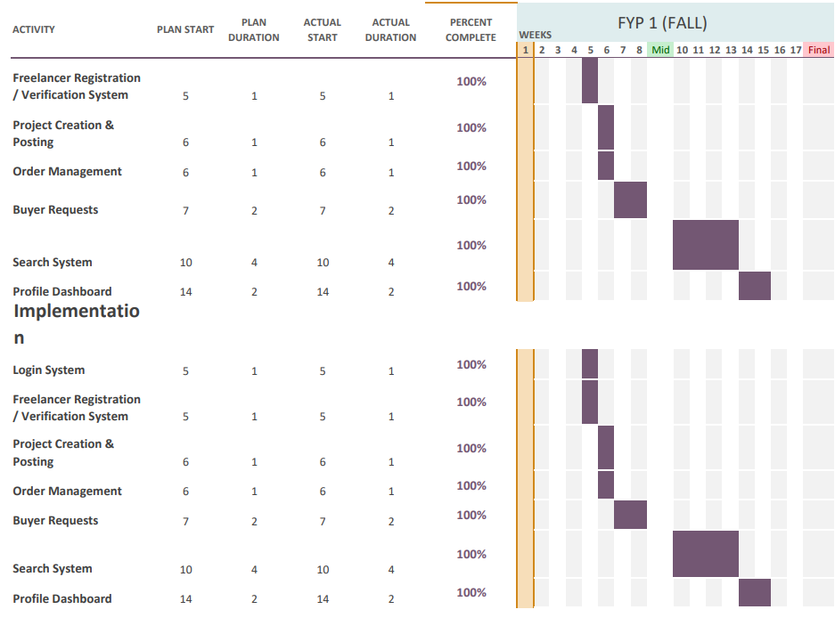

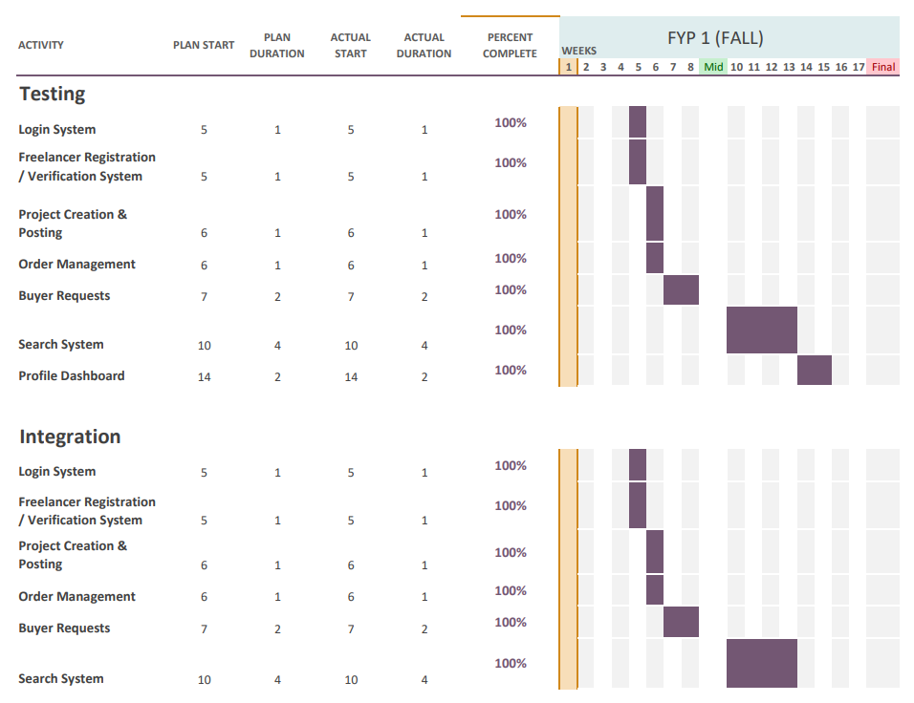

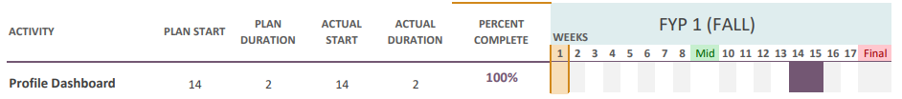

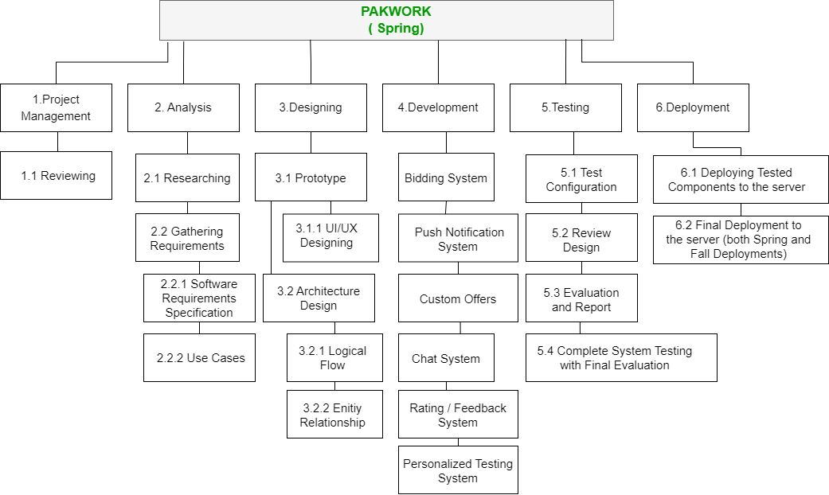**WBS & Gantt Chart (FYP 2) (Spring)**

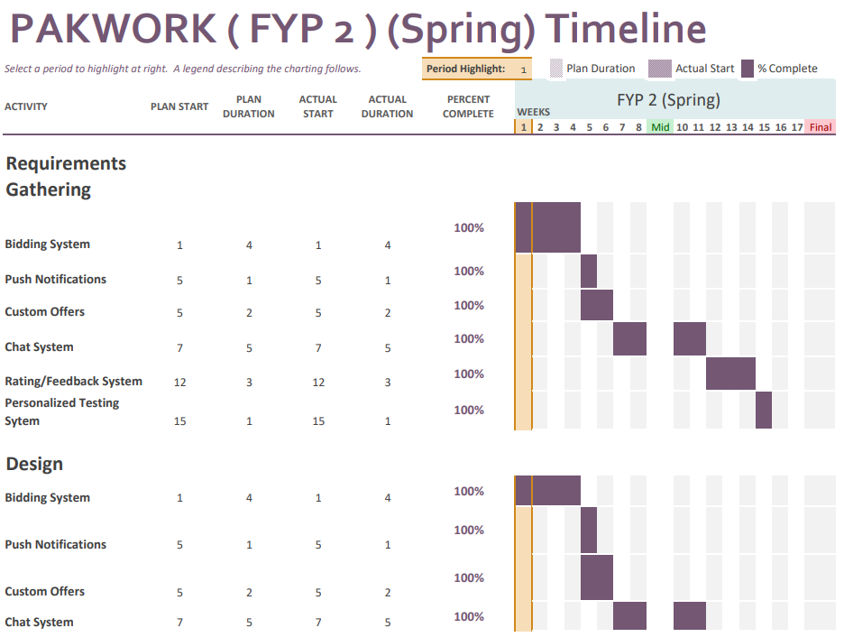

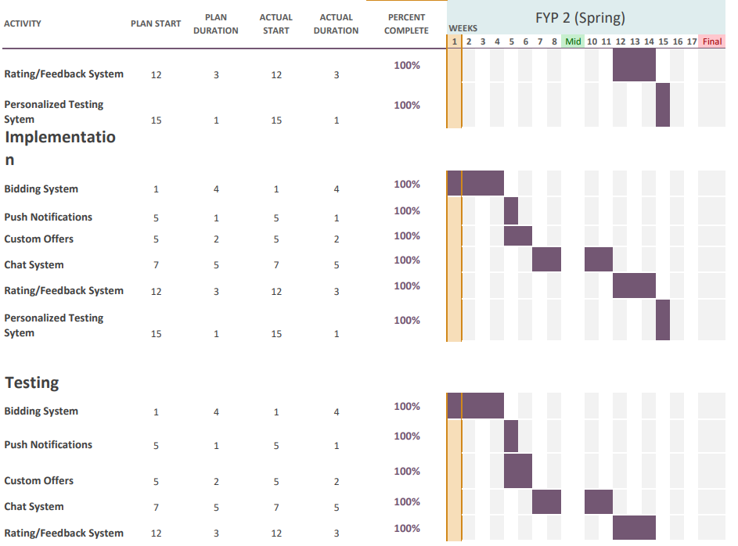

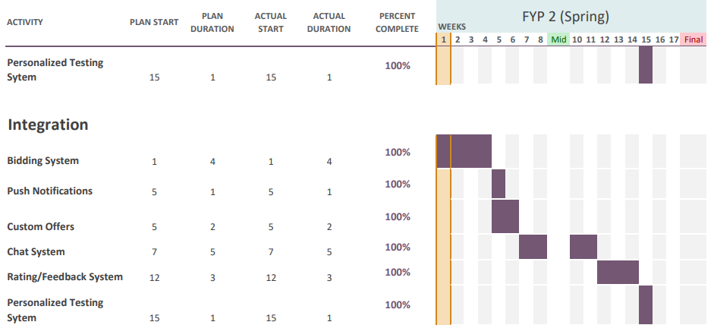

# 13. References

* Daniel Ruby “20+ Freelance Statistics Including All Facts & Data (2022)” DemandSage, August 13th 2022, <https://www.demandsage.com/freelance-statistics/>
* TechAbu “Top 10 Countries with The Most Freelancers 2022” TechAbu, June 12th 2022, <https://techabu.co/freelancing/top-10-countries-with-most-> freelancers

# Software Requirements Specification

# Introduction

## Purpose

A Freelancing platform for freelancers. Where freelancers can easily sell their gigs and offer services to potential clients/businesses. We aim to provide a fully featured platform that provides everything necessary for a seamless process of a transaction between two entities.

## Document Conventions

The format of this SRS is simple. Indentation is used on general topics and or specific points of interest with ‘Times font’ and are in a larger font size compared to the regular text. The headings have been Bold and the text size used is 14 and for the regular text the text size used is 12.

## Intended Audience and Reading Suggestions

This document is to be read by the intended for project manager and teachers. This document is particularly intended for users of the website for understanding the product.

## Product Scope

We aim to create a platform that targets freelancers with much easier policies and regional service charges. On the other hand, to tackle the issue of unprofessional and unskilled freelancers, we aim to provide a customized filtering process to ensure that only professional and skilled freelancers can be allowed to work on the platform. We also provide a customized test related to the job that is being bided by freelancers so that only matched freelancers can bid on outsourced projects by businesses, as this way we can tackle much of the filtering part we can offer to the clients. To tackle the issue of the order policy we will make sure that the freelancer has the choice to accept or decline customer job offers made by the client.

## References

- IEEE Template for System Requirement Specification Documents: <https://goo.gl/nsUFwy>

# Overall Description

## Product Perspective

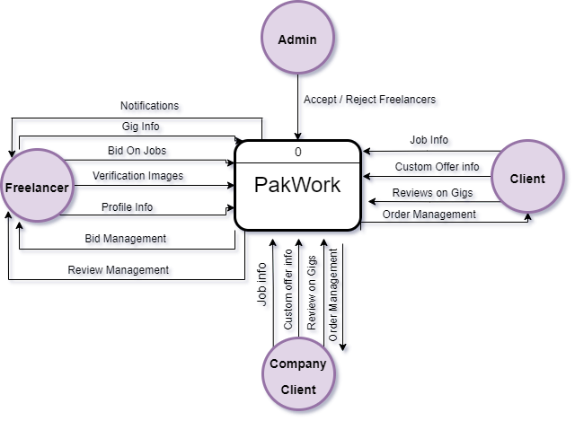

## Product Functions

* Freelancer Registration & Verification System
* Gig / Job Creation & Posting
* Order Management
* Buyer Requests
* Search System
* Profile Dashboard
* Bidding System
* Push Notification System
* Custom Offers
* Chat System
* Rating/Feedback System
* Personalized Testing System

## User Classes and Characteristics

There will be technically 4 types of users in the system

* **Freelancer**: The person that will be providing the services to the clients and the companies
* **Administrator**: The person responsible for verifying the freelancer’s identity
* **Client**: The person that will publish jobs and custom offers to freelancers to do tasks.
* **Company Client**: Company that will publish jobs and custom offers to freelancers to do tasks.

## Operating Environment

* **Software Preferences**: The website requires internet access to the internet and browsers such as Chrome, Firefox, MS Edge, Safari
* **Hardware Preferences**: Website can be accessed using PC/Laptop or Mobile/Tablet

## Design and Implementation Constraints

Some system design limitation constraints come from a payment holding system. Which is a common feature which is used by these platforms to cater claims/disputes. Since we are not implementing a payment gateway system or wallet system, hence we are also not implementing this feature.

## User Documentation

The website is self-explanatory for the user, that’s why no user manual is provided.

## Assumptions and Dependencies

* User must have an active internet connection to access the website
* User must enter valid details into the website
* Proper identification documents are provided to be verified to use the platform

# External Interface Requirements

## User Interfaces

**Main Page**

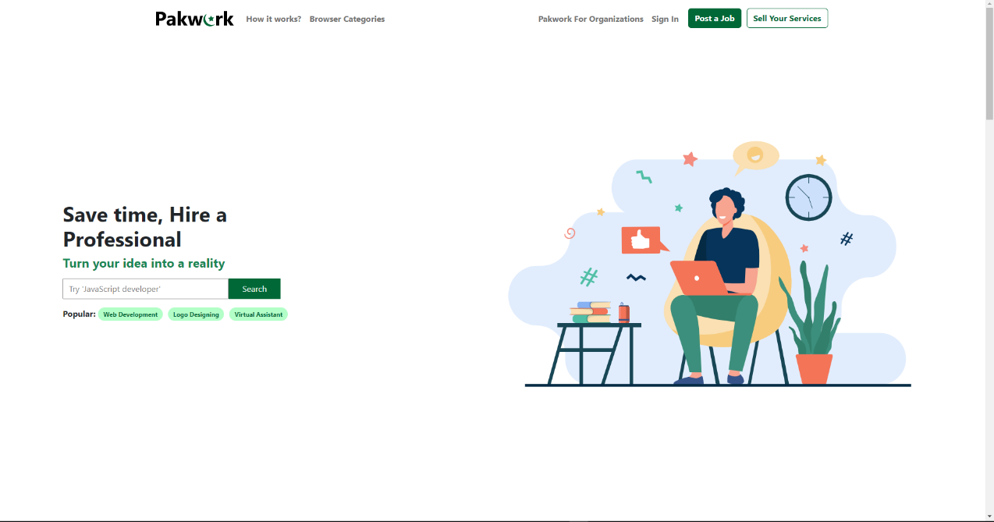

**Freelancer Registration**

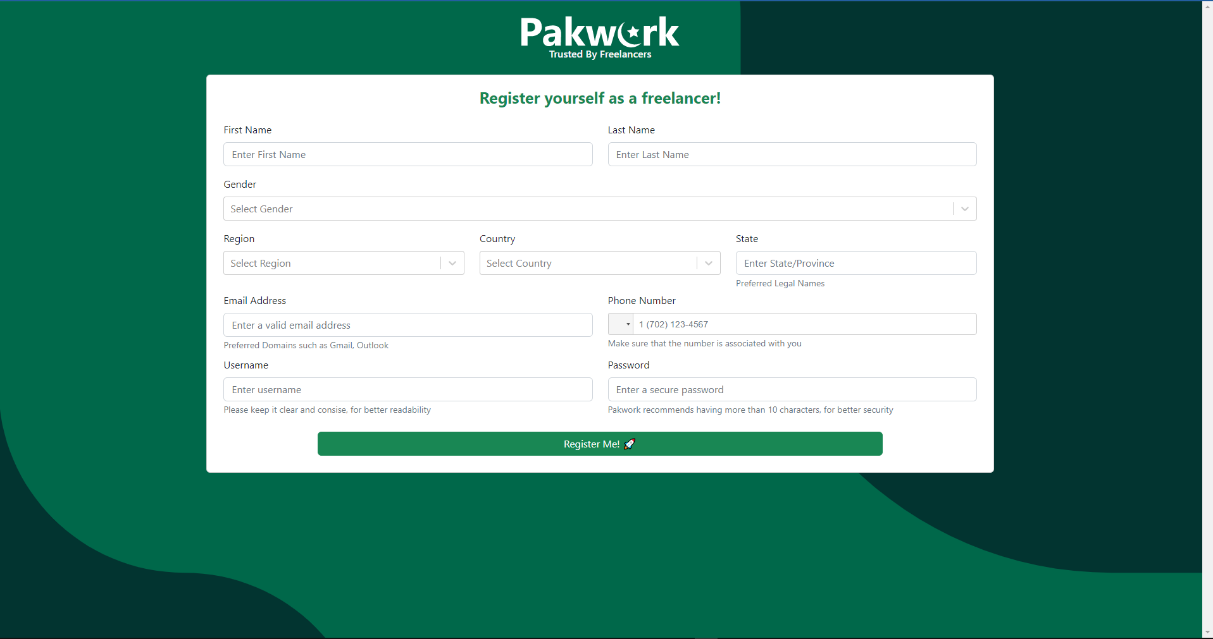

**Client Registration**

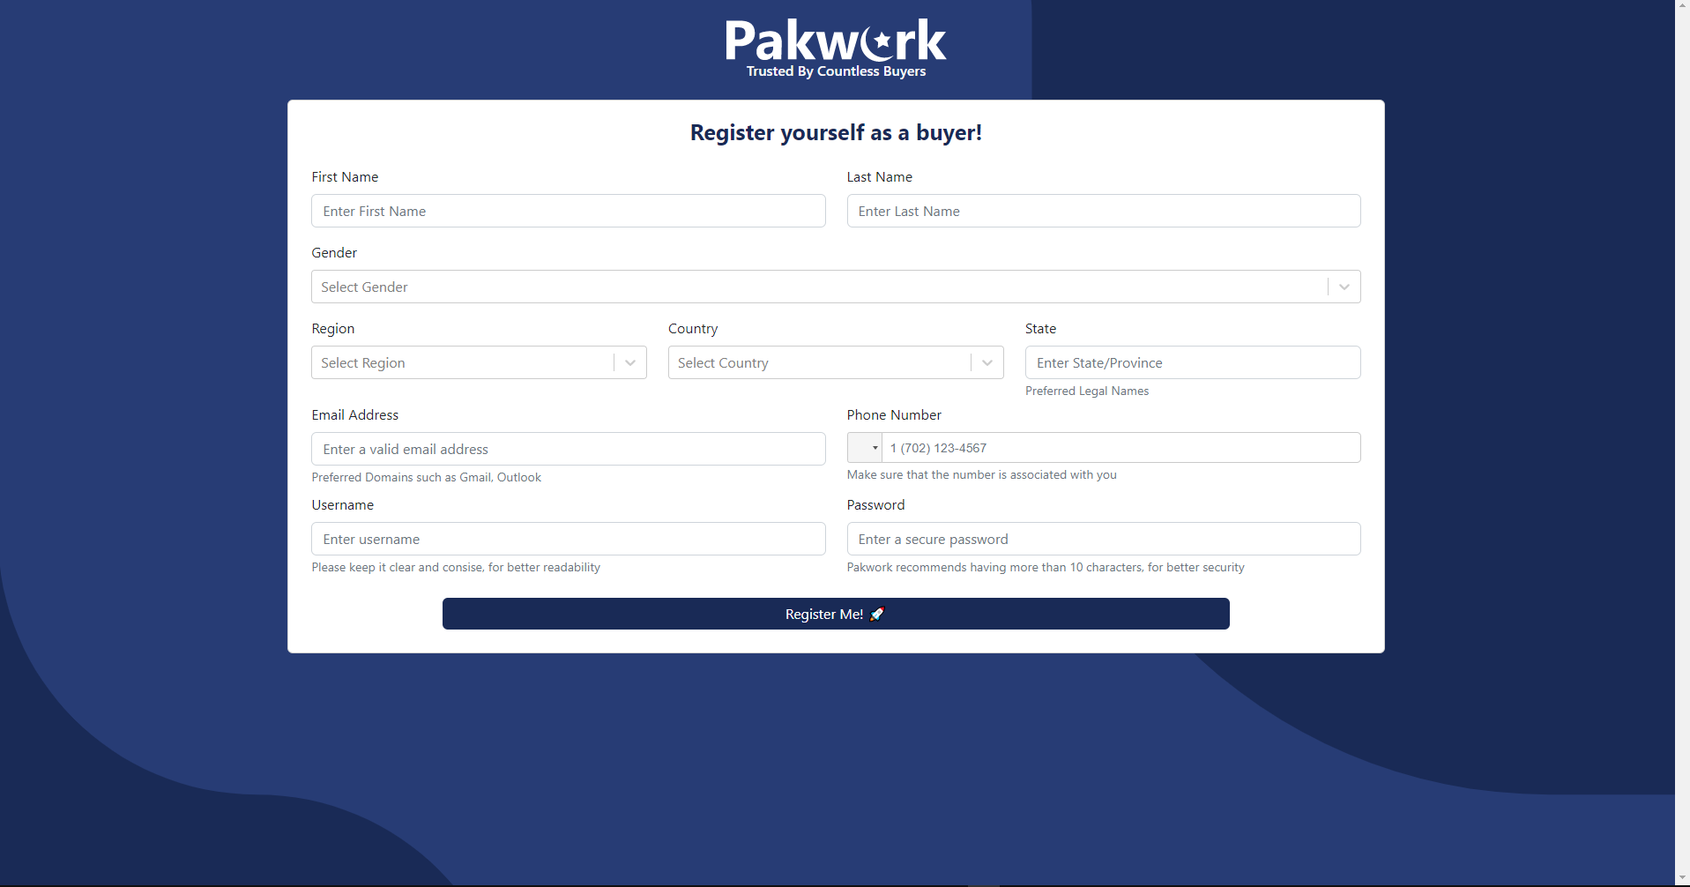

**Company Client Registration**

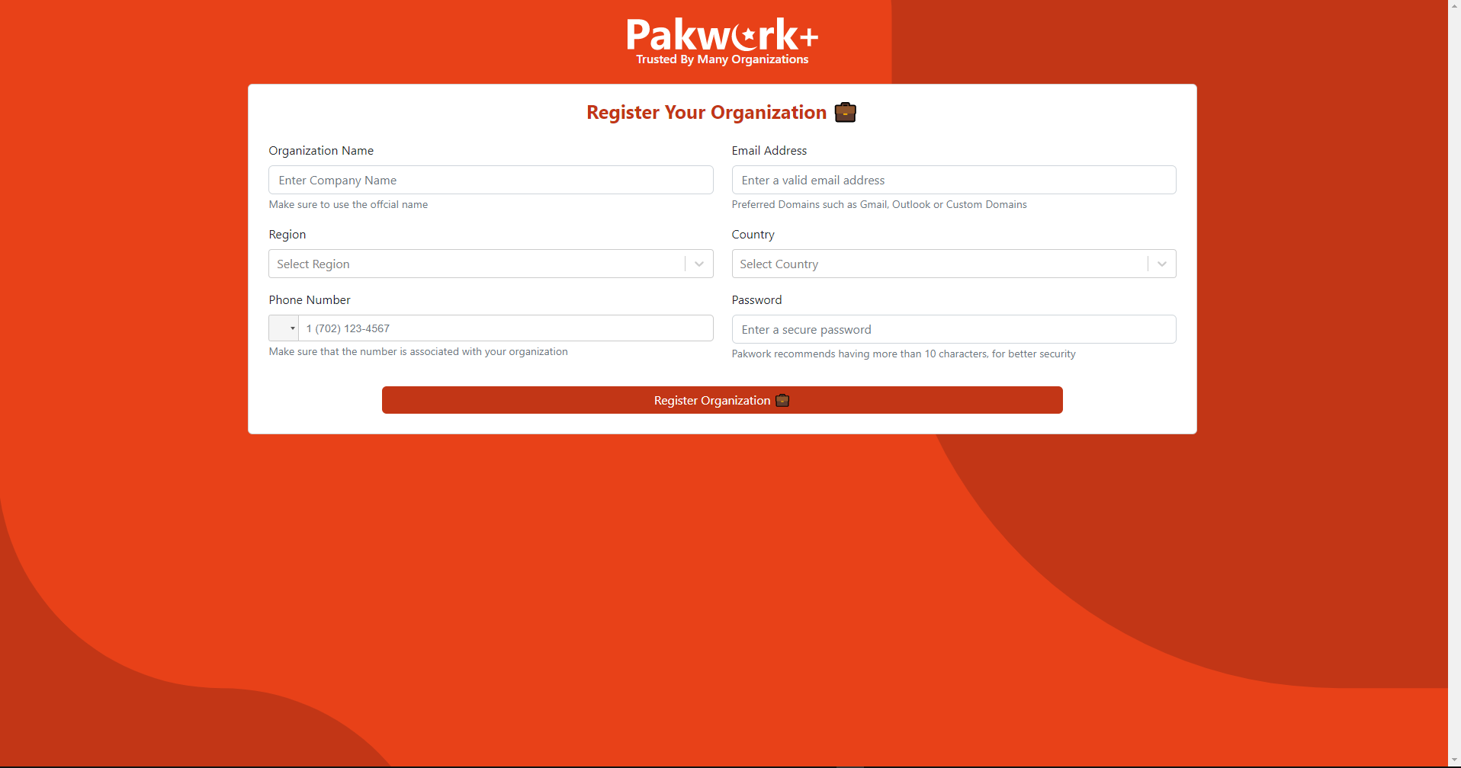

**Profile Dashboard**

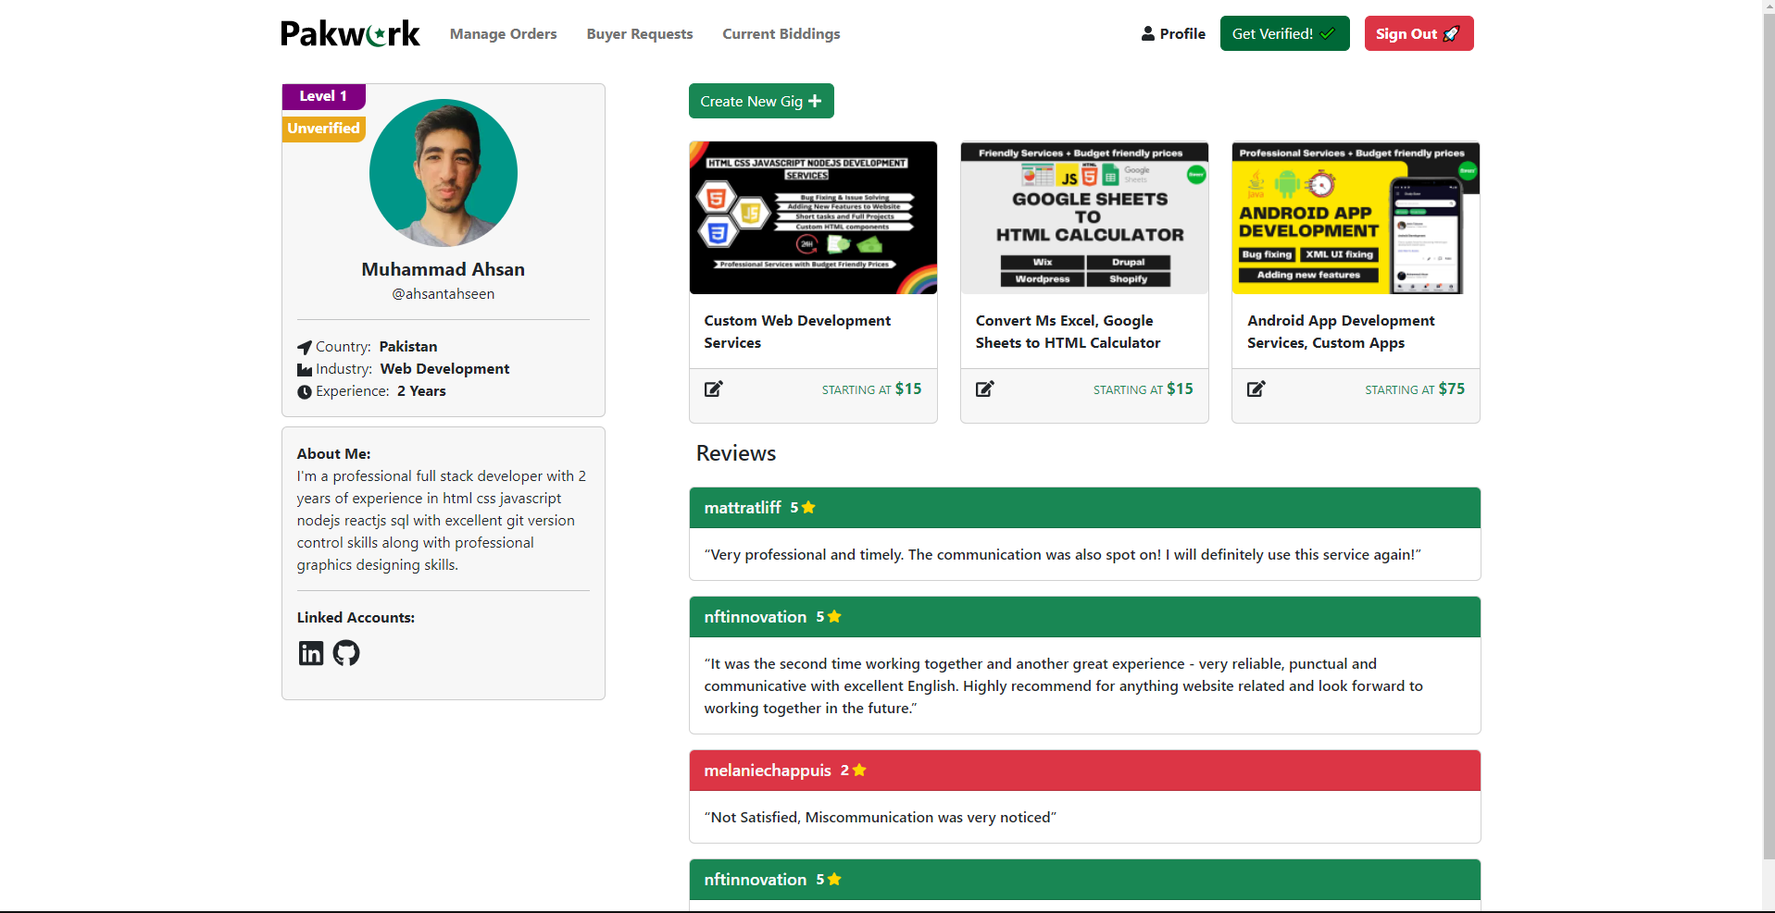

**Upload Verification Images**

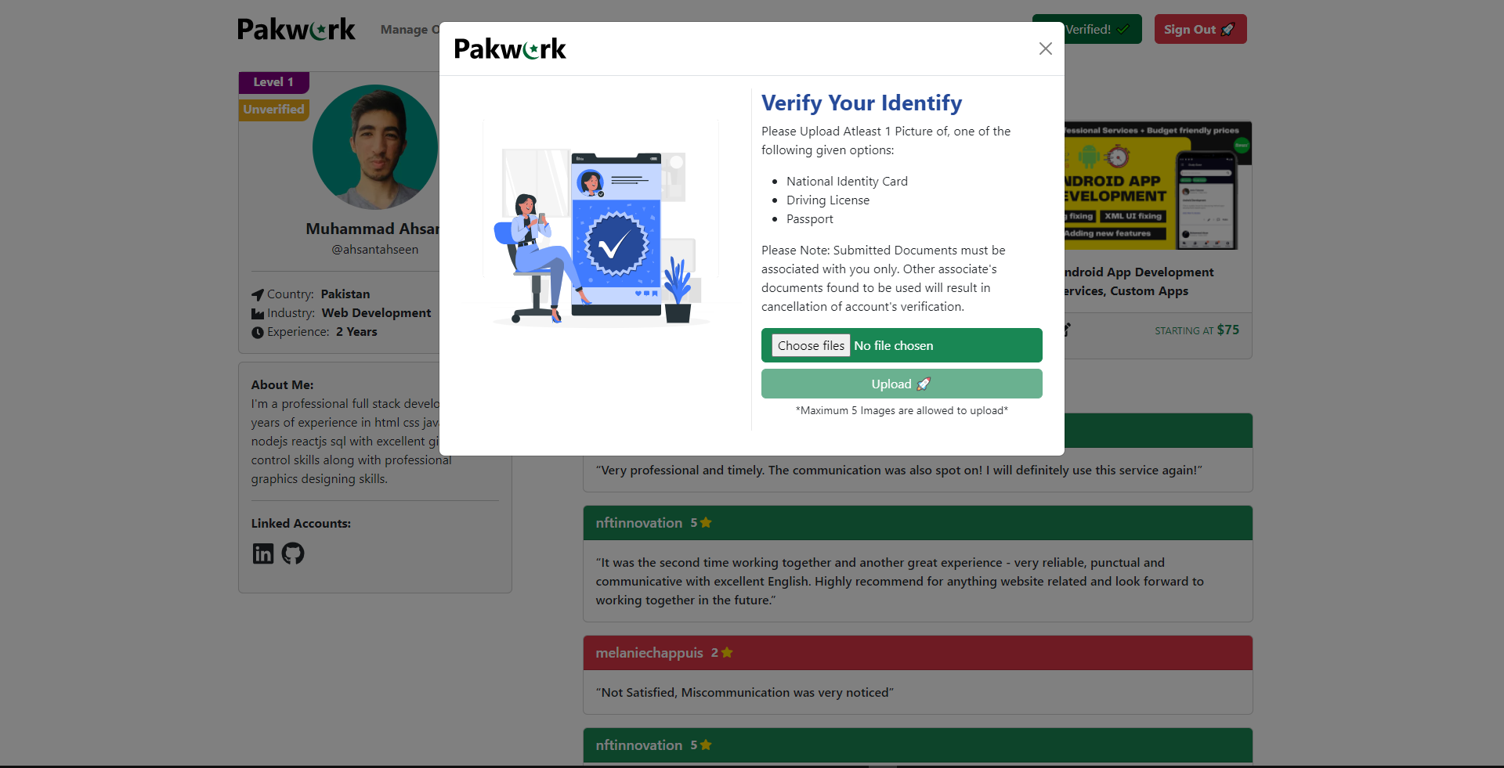

**Administrator Login**

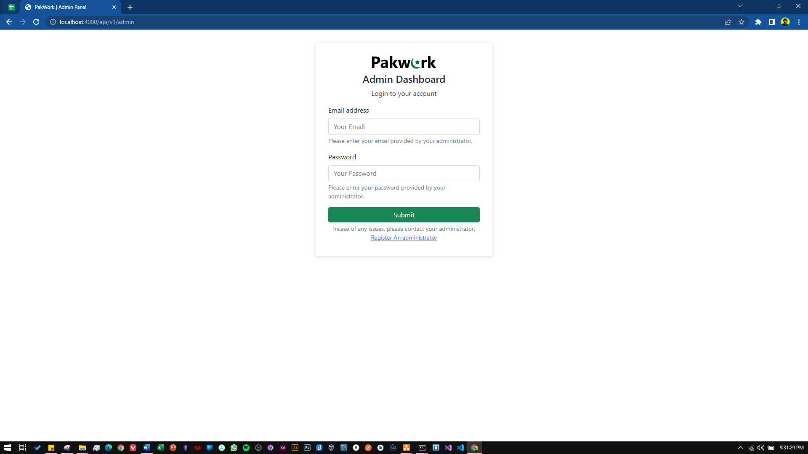

**Displaying Unverified Freelancers**

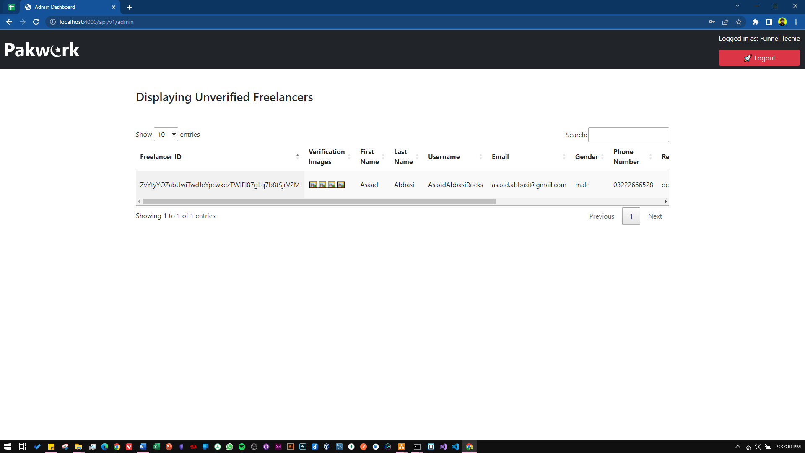

## Hardware Interfaces

No hardware interfaces are required since the software has no direct relation or dependability on an external hardware device. But a good fast internet connection is recommended for usage of the website

## Software Interfaces

* Visual Studio Code
* MySQL
* MongoDB
* Sockets IO

## Communications Interfaces

Communication interface used in this system is HTTP (Hyper Text Transfer Protocol) and WebSocket protocol with polling as a fallback option for chat messages.

# System Features

## Freelancer Registration / Verification System

### Description and Priority

This system is used to register and verify the freelancer before they can start posting gigs and bidding on jobs.

### Stimulus/Response Sequences

#### 

|  |  |  |  |  |  |
| --- | --- | --- | --- | --- | --- |
| **Use Case Name:** | | | Freelancer Registration / Verification System | | |
| **Summary:** | | | Register and verify freelancer before they use the platform | | |
| **User/Actor:** | | | Freelancer, Administrator | | |
| **Preconditions:** | | | * Internet connection necessary * Valid information for registering | | |
| **Basic Course of events/happy path** | | | | | |
| **Step** | | **User Actions** | | | **System Actions** |
| 1 | | Freelancers inputs all valid information in registration field | | | Wait for the registration button to click |
| 2 | | Registration button clicked | | | * System sends an email verification link to user’s email address * Saves data to database |
| 3 | | User Logs In & Uploads verification images | | | * Save verification images in database * Send’s pending request to administrator to foresee |
| Alternate Flow | | | | | |
| **Step** | **User Actions** | | | **System Actions** | |
| 1 | Wrong Username or password entered when logging in | | | Displays an error message “Invalid username or password” | |
| Post conditions | | | | | |
| * Verification request is accepted/rejected by the administrator after which freelancer can use the platform | | | | | |
| Author | | | | | |
| Asaad Noman | | | | | |

### Functional Requirements

|  |  |  |  |  |  |  |  |  |
| --- | --- | --- | --- | --- | --- | --- | --- | --- |
| **Test Case ID** | | PW_001 | **Test Case Description** | | Testing Freelancer Registration / Verification System | | | |
| **Created By** | | Asaad | **Reviewed By** | | Ahsan | | **Version** | | 1.9 |
|  |  |  |  |  |  |  |  |  |  |  |
| **QA Tester’s Log** | | N/A | | | |  |  |  |  |  |
|  |  |  |  |  |  |  |  |  |  |  |
| **Tester's Name** | | Asaad | **Date Tested** | | 9th November 2022 | | **Test Case (Pass/Fail/Not Executed)** | | Pass |
|  |  |  |  |  |  |  |  |  |  |  |
| **S #** | **Prerequisites:** | | |  | **S #** | **Test Data** | | |
| 1 | Access to Chrome Browser | | |  | 1 | email = [asaad@gmail.com](mailto:asaad@gmail.com) | | |
| 2 |  | | |  | 2 | Password = 1234567890 | | |
| 3 |  | | |  | 3 | First_name = Asaad | | |
| 4 |  | | |  | 4 | Last_name = Abbasi | | |
|  |  | | |  |  | Country = Pakistan | | |
|  |  | | |  |  | State = Karachi | | |
|  |  | | |  |  | Region = Asia | | |
|  |  | | |  |  | Phone_number = 03002119222 | | |
|  |  | | |  |  | Username= AsaadNA | | |
|  |  |  |  |  |  |  |  |  |  |  |
| **Test Scenario** | Verify on entering the credentials the freelancer account is created and an email verification link is sent | | | | | |  |  |  |  |
|  |  |  |  |  |  |  |  |  |  |  |
| **Step #** | **Step Details** | | **Expected Results** | | **Actual Results** | | | **Pass / Fail / Not executed / Suspended** |
|
| 1 | Navigate to http://localhost:3000/ | | Site should open | | As Expected | | | Pass |
| 2 | Click “Sell your services” | | Credential can be entered | | As Expected | | | Pass |
| 3 | Click Register | | Freelancer registered | | As Expected | | | Pass |
| 4 | Email verification link sent | | Link sent | | As Expected | | | Pass |

## Gig / Job Creating & Posting

### Description & Priority

This feature is used by the freelancer, client & the company client to post gigs, jobs, custom offers respectively

### Stimulus/Response Sequences

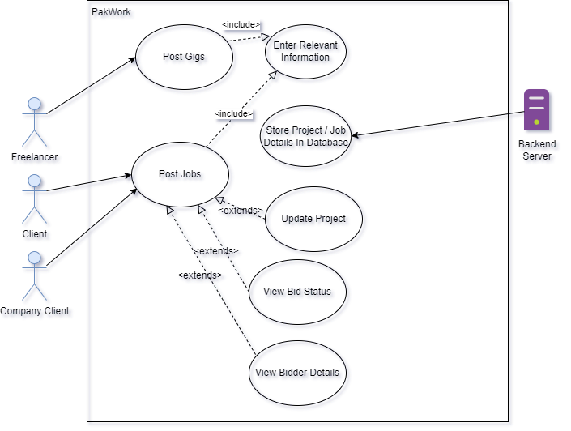

|  |  |  |  |  |  |
| --- | --- | --- | --- | --- | --- |
| **Use Case Name:** | | | Gig/Job Creation & Posting | | |
| **Summary:** | | | Feature used by freelancers, client & company clients to post job, gigs & send custom offers | | |
| **User/Actor:** | | | Freelancer, Client, Company Client | | |
| **Preconditions:** | | | The users of the system must be logged in. | | |
| **Basic Course of events/happy path** | | | | | |
| **Step** | | **User Actions** | | | **System Actions** |
| 1 | | The User clicks the create gig/job button | | | System displays a modal dialog for user to enter the necessary details |
| 2 | | User Clicks Post Button | | | * Job/Gig gets saved in the database * Displayed on the profile dashboard |
| Alternate Flow | | | | | |
| **Step** | **User Actions** | | | **System Actions** | |
| 1 | Some Details are left out and post button is clicked | | | Displays an error message to fill the empty fields | |
| Post conditions | | | | | |
| The website is refreshed and updated information is displayed on the dashboard | | | | | |
| Author | | | | | |
| Asaad Noman | | | | | |

### Functional Requirements

|  |  |  |  |  |  |  |  |  |
| --- | --- | --- | --- | --- | --- | --- | --- | --- |
| **Test Case ID** | | PW_002 | **Test Case Description** | | Testing Gig/Job Posting | | | |
| **Created By** | | Asaad | **Reviewed By** | | Ahsan | | **Version** | | 1.0 |
|  |  |  |  |  |  |  |  |  |  |  |
| **QA Tester’s Log** | | Testing this from the freelancer side | | | |  |  |  |  |  |
|  |  |  |  |  |  |  |  |  |  |  |
| **Tester's Name** | | Asaad | **Date Tested** | | 9th November 2022 | | **Test Case (Pass/Fail/Not Executed)** | | Pass |
|  |  |  |  |  |  |  |  |  |  |  |
| **S #** | **Prerequisites:** | | |  | **S #** | **Test Data** | | |
| 1 | Should be logged in | | |  | 1 | title = Sell Scripts for automation | | |
| 2 | Should be verified & activated | | |  | 2 | startingPrice= 10 | | |
| 3 |  | | |  | 3 | detail = lorem ipsum | | |
|  |  |  |  |  |  |  |  |  |  |  |
| **Test Scenario** | Verify on posting that the gig is posted properly and is displaying | | | | | |  |  |  |  |
|  |  |  |  |  |  |  |  |  |  |  |
| **Step #** | **Step Details** | | **Expected Results** | | **Actual Results** | | | **Pass / Fail / Not executed / Suspended** |
|
| 1 | Navigate to http://localhost:3000/profile/ | | Site should open | | As Expected | | | Pass |
| 2 | Click create Gig button | | Credential can be entered | | As Expected | | | Pass |
| 3 | Click Post | | Gig has been posted | | As Expected | | | Pass |

## Profile Dashboard

### Description & Priority

This feature is basically a dashboard for the user whether it be client. Company client or freelancer. They can view, create their jobs/gigs, change profile picture or update their bio or upload verification images.

### Stimulus/Response Sequences

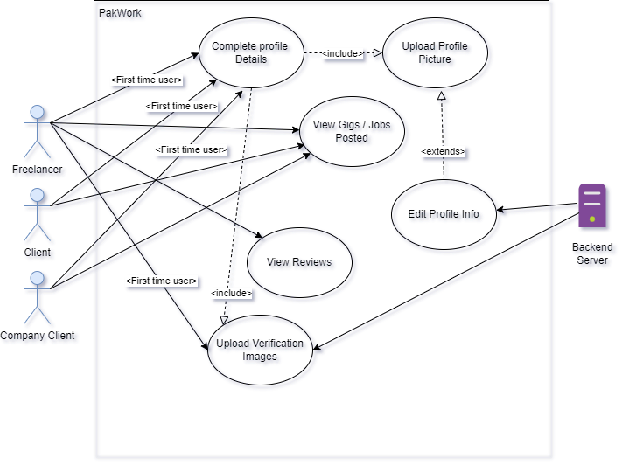

|  |  |  |  |  |  |
| --- | --- | --- | --- | --- | --- |
| **Use Case Name:** | | | Profile Dashboard | | |
| **Summary:** | | | A Feature that allows the users to see and update their profile bio, upload profile pictures, verification images and their gig and jobs posted | | |
| **User/Actor:** | | | Freelancer, Client, Company Client | | |
| **Preconditions:** | | | The users of the system must be logged in. | | |
| **Basic Course of events/happy path** | | | | | |
| **Step** | | **User Actions** | | | **System Actions** |
| 1 | | The user clicks on profile dashboard | | | If profile not completed system tells to complete profile information |
| 2 | | User completes profile info | | | System allows user to view all the necessary information on the profile dashboard |
| Alternate Flow | | | | | |
| **Step** | **User Actions** | | | **System Actions** | |
| 1 | User tries to view profile without completing profile info | | | System continues to show error to complete profile information. | |
| Post conditions | | | | | |
| Every information is available in the profile dashboard for the user to see. | | | | | |
| Author | | | | | |
| Asaad Noman | | | | | |

### Functional Requirements

|  |  |  |  |  |  |  |  |  |
| --- | --- | --- | --- | --- | --- | --- | --- | --- |
| **Test Case ID** | | PW_003 | **Test Case Description** | | Testing the profile dashboard | | | |
| **Created By** | | Asaad | **Reviewed By** | | Ahsan | | **Version** | | 1.0 |
|  |  |  |  |  |  |  |  |  |  |  |
| **QA Tester’s Log** | | Reviewing the freelancer profile | | | |  |  |  |  |  |
|  |  |  |  |  |  |  |  |  |  |  |
| **Tester's Name** | | Asaad | **Date Tested** | | 9th November 2022 | | **Test Case (Pass/Fail/Not Executed)** | | Pass |
|  |  |  |  |  |  |  |  |  |  |  |
| **S #** | **Prerequisites:** | | |  | **S #** | **Test Data** | | |
| 1 | Should be loggedin | | |  | 1 | N/A | | |
|  |  |  |  |  |  |  |  |  |  |  |
| **Test Scenario** | Verify if all the data on profile dashboard is displaying correctly | | | | | |  |  |  |  |
|  |  |  |  |  |  |  |  |  |  |  |
| **Step #** | **Step Details** | | **Expected Results** | | **Actual Results** | | | **Pass / Fail / Not executed / Suspended** |
|
| 1 | Navigate to <http://localhost:3000/profile> | | Site should open | | As Expected | | | Pass |
| 2 | Profile is displayed | | All Information is being displayed | | As Expected | | | Pass |

## Search System

### Description & Priority

This feature will allow the clients and freelancer respectively to search for gigs / jobs on the platform

### Stimulus/Response Sequences

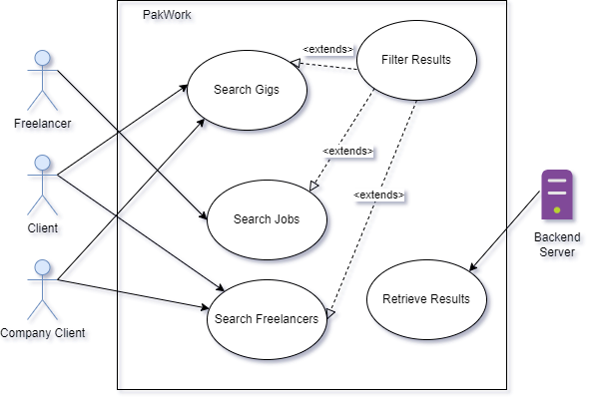

|  |  |  |  |  |  |
| --- | --- | --- | --- | --- | --- |
| **Use Case Name:** | | | Search System | | |
| **Summary:** | | | This feature allows any type of users to search for desired data in the platform | | |
| **User/Actor:** | | | Freelancer, Client, Company Client | | |
| **Preconditions:** | | | Working internet connection | | |
| **Basic Course of events/happy path** | | | | | |
| **Step** | | **User Actions** | | | **System Actions** |
| 1 | | The user clicks on search box | | | Does nothing |
| 2 | | User selects type of information needed to search from combo box | | | Does nothing |
| 3 | | User enters desired text | | | System starts giving suggestion based on the input given |
| 4 | | User presses enter | | | A new page is loaded giving the matched result to the user query |
| Alternate Flow | | | | | |
| **Step** | **User Actions** | | | **System Actions** | |
| 1 | User writes in search box | | | Result is not retrieved, since no matched query from the database. Data does not exist | |
| Post conditions | | | | | |
| Search result is displayed | | | | | |
| Author | | | | | |
| Asaad Noman | | | | | |

### Functional Requirements

|  |  |  |  |  |  |  |  |  |
| --- | --- | --- | --- | --- | --- | --- | --- | --- |
| **Test Case ID** | | PW_004 | **Test Case Description** | | Testing the search system | | | |
| **Created By** | | Asaad | **Reviewed By** | | Ahsan | | **Version** | | 1.0 |
|  |  |  |  |  |  |  |  |  |  |  |
| **QA Tester’s Log** | | N/A | | | |  |  |  |  |  |
|  |  |  |  |  |  |  |  |  |  |  |
| **Tester's Name** | | Asaad | **Date Tested** | | 9th November 2022 | | **Test Case (Pass/Fail/Not Executed)** | | Pass |
|  |  |  |  |  |  |  |  |  |  |  |
| **S #** | **Prerequisites:** | | |  | **S #** | **Test Data** | | |
| 1 | Internet Connectivity | | |  | 1 | Search box: Web Development | | |
|  |  |  |  |  |  |  |  |  |  |  |
| **Test Scenario** | Verify if all the data on profile dashboard is displaying correctly | | | | | |  |  |  |  |
|  |  |  |  |  |  |  |  |  |  |  |
| **Step #** | **Step Details** | | **Expected Results** | | **Actual Results** | | | **Pass / Fail / Not executed / Suspended** |
|
| 1 | Navigate to [http://localhost:3000/](http://localhost:3000/profile) | | Site should open | | As Expected | | | Pass |
| 2 | Click on search box and select type of information needed and start typing | | Information displayed dynamically | | As Expected | | | Pass |
| 3 | Press enter | | New page loaded and information displayed | | As Expected | | | Pass |

## Buyer Requests

### Description & Priority

This is basically a job board dashboard that allows miscellaneous jobs to be posted that do not fit into the categories offered in the platform.

### Stimulus/Response Sequences

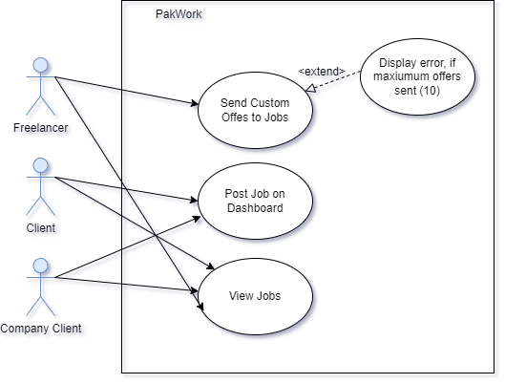

|  |  |  |  |  |  |
| --- | --- | --- | --- | --- | --- |
| **Use Case Name:** | | | Buyer Requests | | |
| **Summary:** | | | This is a job board dashboard for miscellaneous jobs. | | |
| **User/Actor:** | | | Freelancer, Client, Company Client | | |
| **Preconditions:** | | | Should be logged in | | |
| **Basic Course of events/happy path** | | | | | |
| **Step** | | **User Actions** | | | **System Actions** |
| 1 | | The user clicks on buyer request dashboard | | | Displays all the current jobs posted and Create job button depending on the user |
| 2 | | If user is a client/company client, they click create job button | | | Modal Dialog is showed |
| 3 | | User enters desired information about the job | | | System waits for the post button to be clicked |
| 4 | | User clicks the post button | | | New Job has been posted |
| Alternate Flow | | | | | |
| **Step** | **User Actions** | | | **System Actions** | |
| 1 | If user is a freelancer, inputs the bid | | | Does nothing | |
| 2 | User clicks the bid now button | | | New Bid has been placed and the bid is updated on the screen | |
| Author | | | | | |
| Asaad Noman | | | | | |

## Order Management

### Description & Priority

This is an order management feature where freelancers, clients and company clients can manage their orders respectively.

### Stimulus/Response Sequences

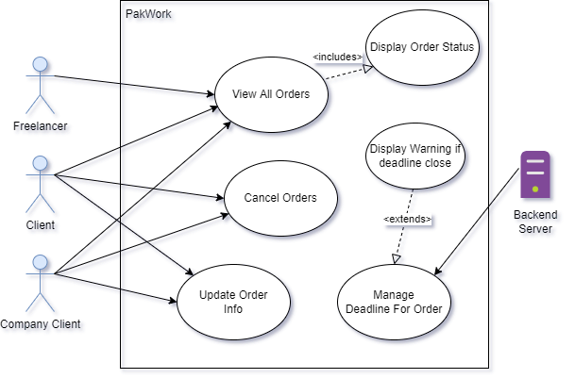

|  |  |  |  |
| --- | --- | --- | --- |
| **Use Case Name:** | | Order Management | |
| **Summary:** | | This is an order management dashboard to manage the orders for freelancers, clients and company clients | |
| **User/Actor:** | | Freelancer, Client, Company Client | |
| **Preconditions:** | | * Should be logged in * Some order should be in progress | |
| **Basic Course of events/happy path** | | | |
| **Step** | **User Actions** | | **System Actions** |
| 1 | The user clicks on order management dashboard | | System displays all the orders in a list |
| Author | | | |
| Asaad Noman | | | |

## Custom Offers

### Description & Priority

This is a feature only for clients and company clients, to send custom offers to their desired/scouted freelancers.

### Stimulus/Response Sequences

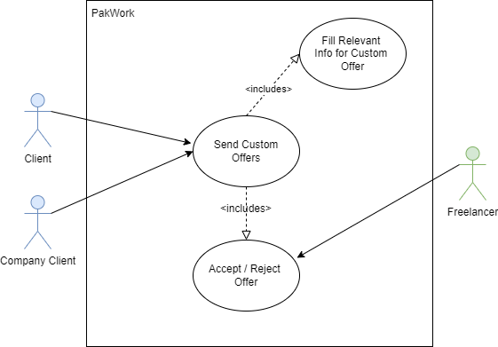

|  |  |  |  |
| --- | --- | --- | --- |
| **Use Case Name:** | | Custom Offers | |
| **Summary:** | | This feature allows clients and company clients to send custom offers to freelancers of their choice. | |
| **User/Actor:** | | Freelancer, Client, Company Client | |
| **Preconditions:** | | The users of the system must be logged in. | |
| **Basic Course of events/happy path** | | | |
| **Step** | **User Actions** | | **System Actions** |
| 1 | The user clicks on profile of freelancer | | System displays all information of the freelancers on a new page |
| 2 | User clicks custom offer buttons | | System shows a modal dialog for inputting information |
| 3 | User fills all info and clicks the send offer button | | Offer is sent to the freelancer and is awaiting response |
| Post conditions | | | |
| The offer status is pending until freelancer sees it and accepts or rejects the custom offer | | | |
| Author | | | |
| Asaad Noman | | | |

## Bidding System

### Description & Priority

This is a bidding system for jobs, freelancers can bid on jobs and compete with other freelancers to quote the best price for a project.

### Stimulus/Response Sequences

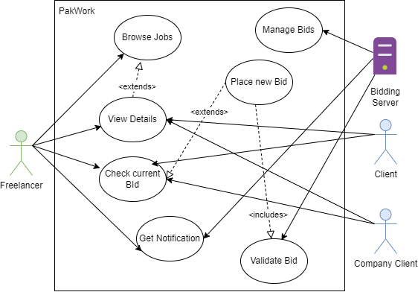

|  |  |  |  |  |  |
| --- | --- | --- | --- | --- | --- |
| **Use Case Name:** | | | Bidding System | | |
| **Summary:** | | | This is a bidding system for jobs, freelancers can bid on jobs and compete with other freelancers to quote the best price for a project. | | |
| **User/Actor:** | | | Freelancer, Client, Company Client | | |
| **Preconditions:** | | | Should be logged in | | |
| **Basic Course of events/happy path** | | | | | |
| **Step** | | **User Actions** | | | **System Actions** |
| 1 | | Freelancer views all the jobs listed | | | Does Nothing |
| 2 | | Freelancer clicks detail button on the job posting | | | System shows all the relevant description and files related to the job posted |
| 3 | | Freelancer enters bid and clicks the bid now button | | | System validates the bid, if all correct, bid is placed |
| Alternate Flow | | | | | |
| **Step** | **User Actions** | | | **System Actions** | |
| 1 | If user is a freelancer, inputs an invalid bid | | | Displays an error message | |
| Author | | | | | |
| Asaad Noman | | | | | |

## Push Notification System

### Description & Priority

This notification system is used to notify user, if they have been outbidded or not, if they received a new chat message or custom offer.

### Stimulus/Response Sequences

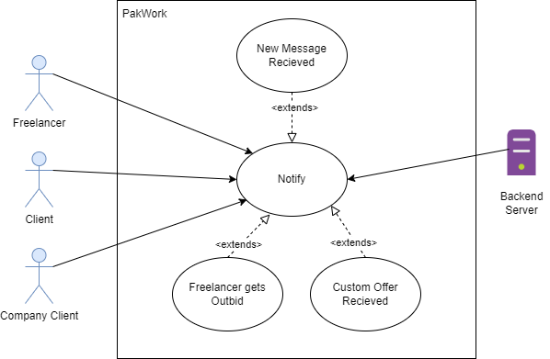

|  |  |  |  |
| --- | --- | --- | --- |
| **Use Case Name:** | | Push Notification System | |
| **Summary:** | | This system allows the users to get notified when certain actions take place such as new message, outbid on jobs, custom offers | |
| **User/Actor:** | | Freelancer, Client, Company Client | |
| **Preconditions:** | | The users of the system must be logged in. | |
| **Basic Course of events/happy path** | | | |
| **Step** | **User Actions** | | **System Actions** |
| 1 | The user gets outbid on project | | Sends a notification to the user, intimating of the outbid |
| Author | | | |
| Asaad Noman | | | |

## Chat System

### Description & Priority

A Feature that can be used by the freelancer & clients respectively to communication with each other without leaving the platform.

### Stimulus/Response Sequences

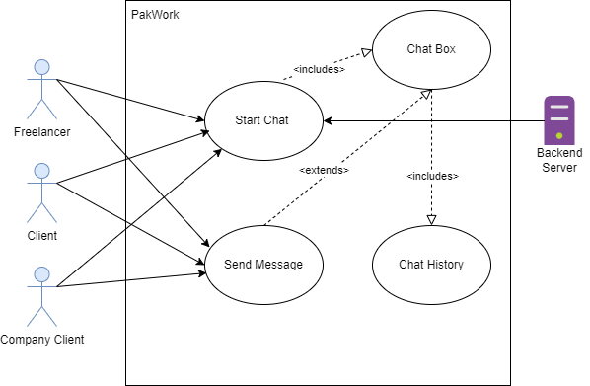

|  |  |  |  |
| --- | --- | --- | --- |
| **Use Case Name:** | | Chat System | |
| **Summary:** | | A Feature that can be used by the freelancer & clients respectively to communication with each other without leaving the platform. | |
| **User/Actor:** | | Freelancer, Client, Company Client | |
| **Preconditions:** | | Should be logged in | |
| **Basic Course of events/happy path** | | | |
| **Step** | **User Actions** | | **System Actions** |
| 1 | Opens Chat Dashboard | | Displays All User list with the user has chat with |
| 2 | Selects A User from list | | Retrieves chat history from database and opens up a chat box with a socket connection |
| 3 | User sends message | | Using sockets message is sent and message is stored in the database |
| Author | | | |
| Asaad Noman | | | |

## Rating/Feedback System

### Description & Priority

This rating and feedback system is a feature for clients and company clients to leave a review of the work/performance of the freelancer on the job. This helps other user to differentiate between good and bad freelancers. Also helps the search system.

### Stimulus/Response Sequences

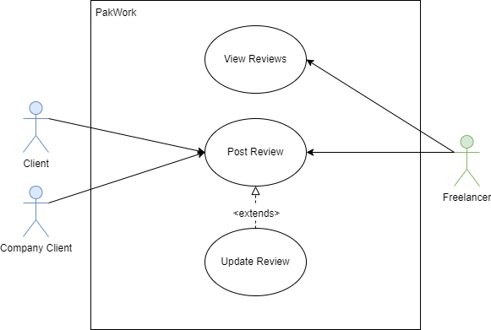

|  |  |  |  |  |  |
| --- | --- | --- | --- | --- | --- |
| **Use Case Name:** | | | Rating/Feedback System | | |
| **Summary:** | | | This rating and feedback system is a feature for clients and company clients to leave a review of the work/performance of the freelancer on the job. This helps other user to differentiate between good and bad freelancers. Also helps the search system. | | |
| **User/Actor:** | | | Freelancer, Client, Company Client | | |
| **Preconditions:** | | | * Should be logged in * Must be a verified buyer of the services of the freelancer | | |
| **Basic Course of events/happy path** | | | | | |
| **Step** | | **User Actions** | | | **System Actions** |
| 1 | | Click the post a review button | | | Open up a modal dialog |
| 2 | | User enters the details of the review, rating etc. | | | Does nothing |
| 3 | | Clicks the submit button | | | System saves the review in the database and refreshes |
| Alternate Flow | | | | | |
| **Step** | **User Actions** | | | **System Actions** | |
| 1 | User tries to submit without filling all information | | | Displays an error message | |
| Author | | | | | |
| Asaad Noman | | | | | |

## Personalized Testing System

### Description & Priority

This feature is available only to the Company client. This allows to set a test before project bidding for freelancer to filter the good ones from the bad ones. Also allows to create a customized test.

### Stimulus/Response Sequences

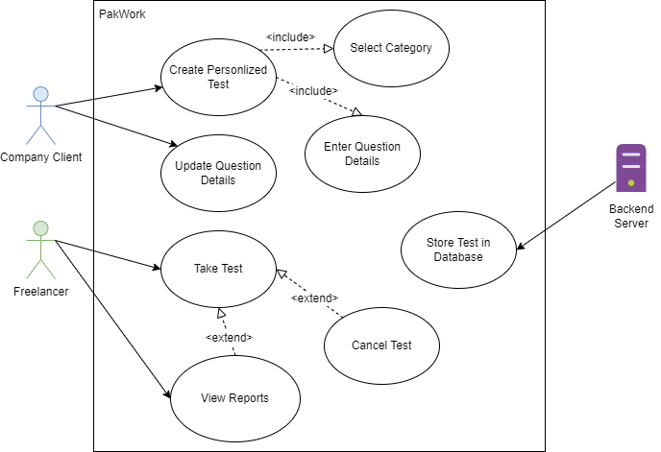

|  |  |  |  |
| --- | --- | --- | --- |
| **Use Case Name:** | | Personalized Testing System | |
| **Summary:** | | This feature is available only to the Company client. This allows to set a test before project bidding for freelancer to filter the good ones from the bad ones. Also allows to create a customized test. | |
| **User/Actor:** | | Freelancer, Company Client | |
| **Preconditions:** | | * Should be logged in * Must be logged in as a company client | |
| **Basic Course of events/happy path** | | | |
| **Step** | **User Actions** | | **System Actions** |
| 1 | Click the create test button | | Open up a modal dialog |
| 2 | User enters the details of the test and adds questions | | Does nothing |
| 3 | Clicks the submit button | | Saves the question in the database |
| 4 | Sets the test when posting new job | | System will ask freelancer to first take the test |
| Author | | | |
| Asaad Noman | | | |

# Other Nonfunctional Requirements

## Performance Requirements

N/A

## Safety Requirements

Do not deal with clients outside platform, for avoidance of being scammed.

## Security Requirements

Freelancer verification should be done thoroughly to avoid the problem of impersonation and multiple profiles of the same person on the platform to maintain the integrity of the system. All information must be placed securely to avoid data loss and invasion of privacy.

## Software Quality Attributes

* **Correctness**: The website should work as expected and contain minimal error and also should be bug free. It is achieved by systematically testing the system and its different components.
* **Maintainability**: System design of the website is done in such a way that it would be easy for the developer to maintain and fix the problems in the future.
* **Usability**: The use interface of the website is designed in such a way that it is easy to navigate and all features are self-explanatory.
* **Reliability**: The website provides secure and integrated communication system that connects freelancers to their clients with ease without making the need to leave the platform.
* **Testability**: This is a necessary attribute for SQA. This is thoroughly done as stated in the testing documents.

## Business Rules

N/A

# Other Requirements

N/A

Appendix A: Glossary

|  |  |  |
| --- | --- | --- |
| S.no | Terms | Description |
| 1 | User Interface | The means by which computer system interact with the user |
| 2 | Database | A structured set of data held in a computer |
| 3 | Sockets | A socket is a software architecture within a network node of a computer network that serves as an endpoint for receiving and sending data across a network |
| 4 | HTTP | Hypertext transfer protocol is a communication interface |

Appendix B: Analysis Models

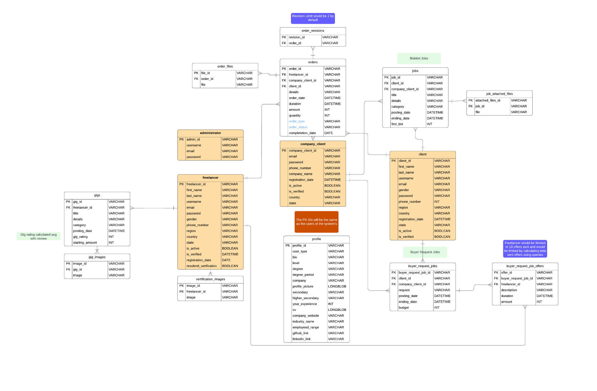ERD:

System Use Case Diagram:

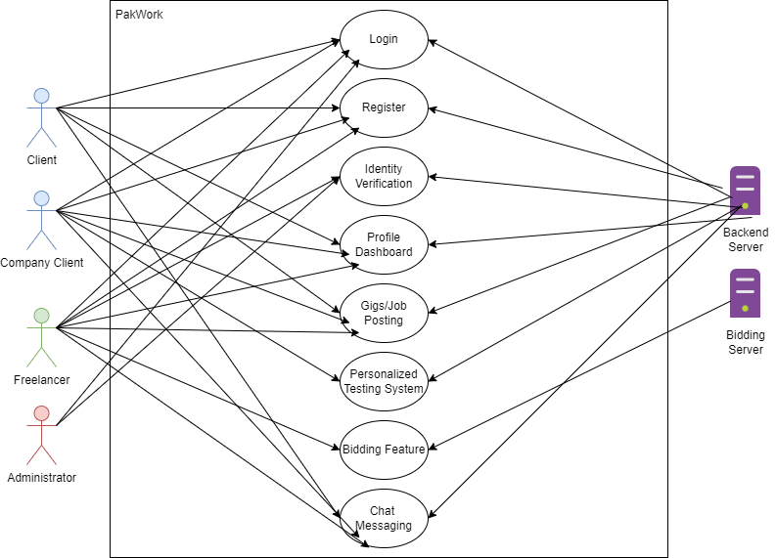

Domain Model:

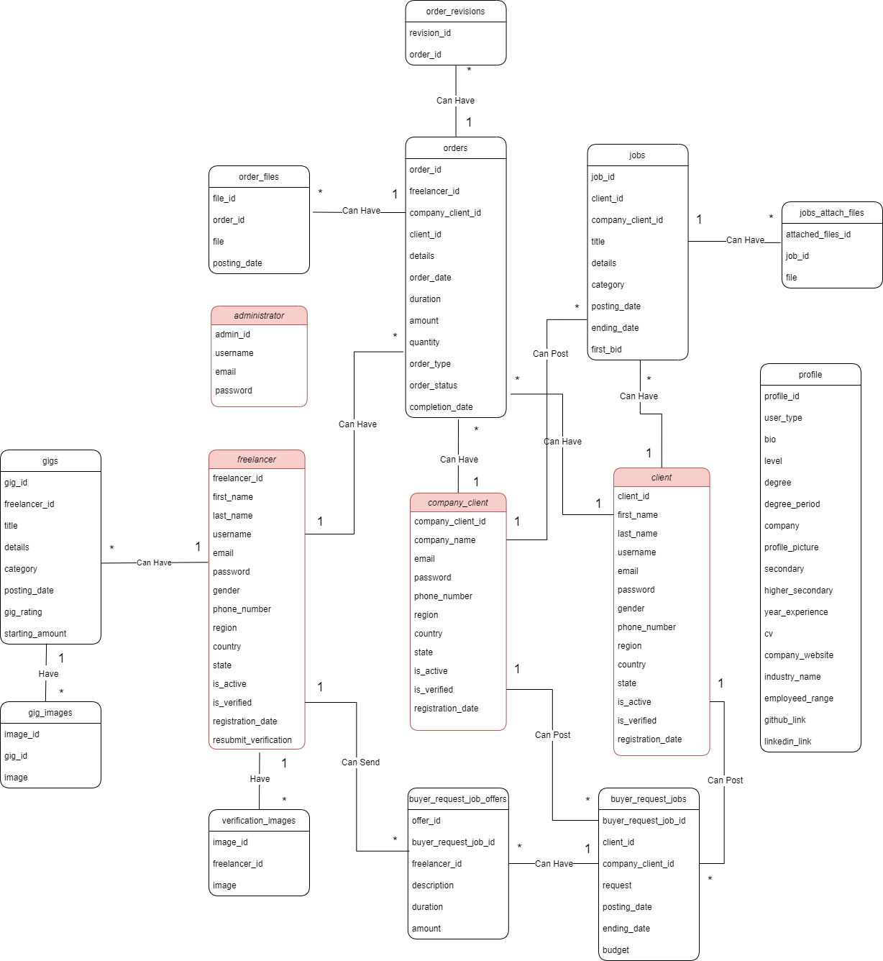

Appendix C: To Be Determined List

N/A

# Testing Documents

**1. Freelancer Registration/Verification System**

|  |  |  |  |  |  |  |  |  |
| --- | --- | --- | --- | --- | --- | --- | --- | --- |
| **Test Case ID** | | PW_001 | **Test Case Description** | | Testing Freelancer Registration / Verification System | | | |
| **Created By** | | Asaad | **Reviewed By** | | Ahsan | | **Version** | | 1.9 |
|  |  |  |  |  |  |  |  |  |  |  |
| **QA Tester’s Log** | | N/A | | | |  |  |  |  |  |
|  |  |  |  |  |  |  |  |  |  |  |
| **Tester's Name** | | Asaad | **Date Tested** | | 9th November 2022 | | **Test Case (Pass/Fail/Not Executed)** | | Pass |
|  |  |  |  |  |  |  |  |  |  |  |
| **S #** | **Prerequisites:** | | |  | **S #** | **Test Data** | | |
| 1 | Access to Chrome Browser | | |  | 1 | email = [asaad@gmail.com](mailto:asaad@gmail.com) | | |
| 2 |  | | |  | 2 | Password = 1234567890 | | |
| 3 |  | | |  | 3 | First_name = Asaad | | |
| 4 |  | | |  | 4 | Last_name = Abbasi | | |
|  |  | | |  |  | Country = Pakistan | | |
|  |  | | |  |  | State = Karachi | | |
|  |  | | |  |  | Region = Asia | | |
|  |  | | |  |  | Phone_number = 03002119222 | | |
|  |  | | |  |  | Username= AsaadNA | | |
|  |  |  |  |  |  |  |  |  |  |  |
| **Test Scenario** | Verify on entering the credentials the freelancer account is created and an email verification link is sent | | | | | |  |  |  |  |
|  |  |  |  |  |  |  |  |  |  |  |
| **Step #** | **Step Details** | | **Expected Results** | | **Actual Results** | | | **Pass / Fail / Not executed / Suspended** |
|
| 1 | Navigate to http://localhost:3000/ | | Site should open | | As Expected | | | Pass |
| 2 | Click “Sell your services” | | Credential can be entered | | As Expected | | | Pass |
| 3 | Click Register | | Freelancer registered | | As Expected | | | Pass |
| 4 | Email verification link sent | | Link sent | | As Expected | | | Pass |

**2. Gig/Job Posting**

|  |  |  |  |  |  |  |  |  |
| --- | --- | --- | --- | --- | --- | --- | --- | --- |
| **Test Case ID** | | PW_002 | **Test Case Description** | | Testing Gig/Job Posting | | | |
| **Created By** | | Asaad | **Reviewed By** | | Ahsan | | **Version** | | 1.0 |
|  |  |  |  |  |  |  |  |  |  |  |
| **QA Tester’s Log** | | Testing this from the freelancer side | | | |  |  |  |  |  |
|  |  |  |  |  |  |  |  |  |  |  |
| **Tester's Name** | | Asaad | **Date Tested** | | 9th November 2022 | | **Test Case (Pass/Fail/Not Executed)** | | Pass |
|  |  |  |  |  |  |  |  |  |  |  |
| **S #** | **Prerequisites:** | | |  | **S #** | **Test Data** | | |
| 1 | Should be logged in | | |  | 1 | title = Sell Scripts for automation | | |
| 2 | Should be verified & activated | | |  | 2 | startingPrice= 10 | | |
| 3 |  | | |  | 3 | detail = lorem ipsum | | |
|  |  |  |  |  |  |  |  |  |  |  |
| **Test Scenario** | Verify on posting that the gig is posted properly and is displaying | | | | | |  |  |  |  |
|  |  |  |  |  |  |  |  |  |  |  |
| **Step #** | **Step Details** | | **Expected Results** | | **Actual Results** | | | **Pass / Fail / Not executed / Suspended** |
|
| 1 | Navigate to http://localhost:3000/profile/ | | Site should open | | As Expected | | | Pass |
| 2 | Click create Gig button | | Credential can be entered | | As Expected | | | Pass |
| 3 | Click Post | | Gig has been posted | | As Expected | | | Pass |

**3. Profile Dashboard**

|  |  |  |  |  |  |  |  |  |
| --- | --- | --- | --- | --- | --- | --- | --- | --- |
| **Test Case ID** | | PW_003 | **Test Case Description** | | Testing the profile dashboard | | | |
| **Created By** | | Asaad | **Reviewed By** | | Ahsan | | **Version** | | 1.0 |
|  |  |  |  |  |  |  |  |  |  |  |
| **QA Tester’s Log** | | Reviewing the freelancer profile | | | |  |  |  |  |  |
|  |  |  |  |  |  |  |  |  |  |  |
| **Tester's Name** | | Asaad | **Date Tested** | | 9th November 2022 | | **Test Case (Pass/Fail/Not Executed)** | | Pass |
|  |  |  |  |  |  |  |  |  |  |  |
| **S #** | **Prerequisites:** | | |  | **S #** | **Test Data** | | |
| 1 | Should be loggedin | | |  | 1 | N/A | | |
|  |  |  |  |  |  |  |  |  |  |  |
| **Test Scenario** | Verify if all the data on profile dashboard is displaying correctly | | | | | |  |  |  |  |
|  |  |  |  |  |  |  |  |  |  |  |
| **Step #** | **Step Details** | | **Expected Results** | | **Actual Results** | | | **Pass / Fail / Not executed / Suspended** |
|
| 1 | Navigate to <http://localhost:3000/profile> | | Site should open | | As Expected | | | Pass |
| 2 | Profile is displayed | | All Information is being displayed | | As Expected | | | Pass |

**4. Search System**

|  |  |  |  |  |  |  |  |  |
| --- | --- | --- | --- | --- | --- | --- | --- | --- |
| **Test Case ID** | | PW_004 | **Test Case Description** | | Testing the search system | | | |
| **Created By** | | Asaad | **Reviewed By** | | Ahsan | | **Version** | | 1.0 |
|  |  |  |  |  |  |  |  |  |  |  |
| **QA Tester’s Log** | | N/A | | | |  |  |  |  |  |
|  |  |  |  |  |  |  |  |  |  |  |
| **Tester's Name** | | Asaad | **Date Tested** | | 9th November 2022 | | **Test Case (Pass/Fail/Not Executed)** | | Pass |
|  |  |  |  |  |  |  |  |  |  |  |
| **S #** | **Prerequisites:** | | |  | **S #** | **Test Data** | | |
| 1 | Internet Connectivity | | |  | 1 | Search box: Web Development | | |
|  |  |  |  |  |  |  |  |  |  |  |
| **Test Scenario** | Verify if all the data on profile dashboard is displaying correctly | | | | | |  |  |  |  |
|  |  |  |  |  |  |  |  |  |  |  |
| **Step #** | **Step Details** | | **Expected Results** | | **Actual Results** | | | **Pass / Fail / Not executed / Suspended** |
|
| 1 | Navigate to [http://localhost:3000/](http://localhost:3000/profile) | | Site should open | | As Expected | | | Pass |
| 2 | Click on search box and select type of information needed and start typing | | Information displayed dynamically | | As Expected | | | Pass |
| 3 | Press enter | | New page loaded and information displayed | | As Expected | | | Pass |

# Diagrams

## 1. System Sequence Diagrams

### 1.1 Freelancer Registration/Verification System

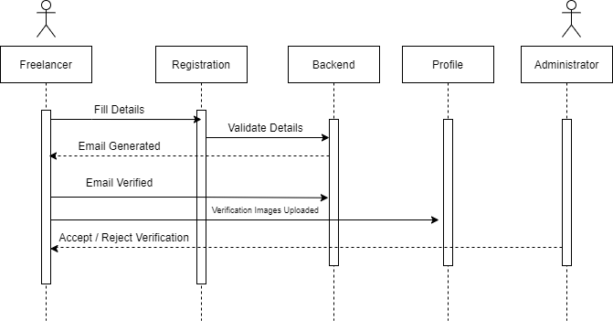

**1.2 Gigs / Job Posting**

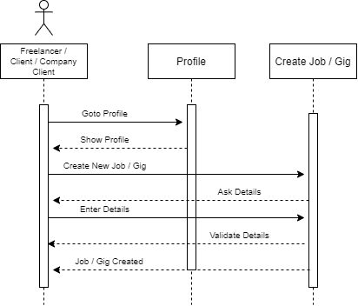

**1.3 Profile Dashboard**

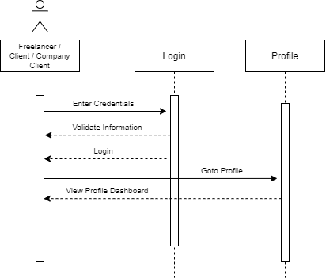

**1.4 Search System**

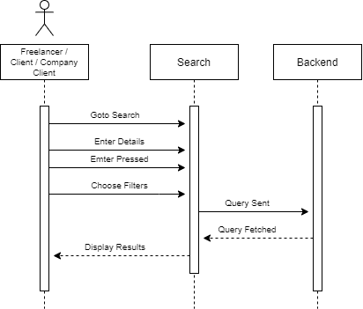

**1.5 Buyer Requests**

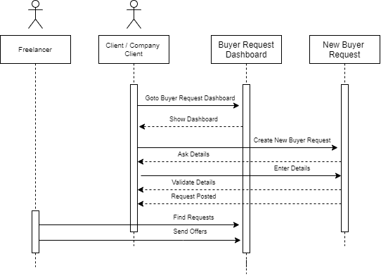

**1.6 Order Management**

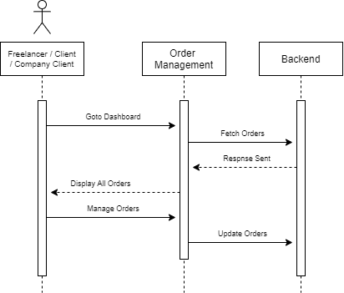

**1.7 Custom Offers**

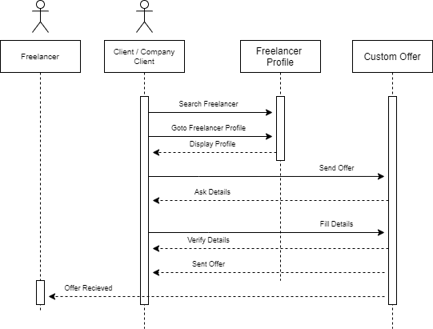

**1.8 Bidding System**

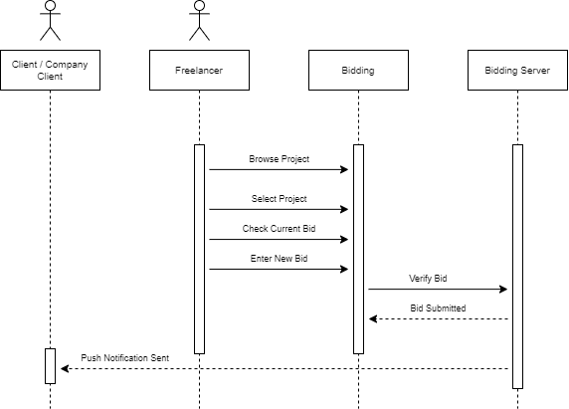

**1.9 Push Notification System**

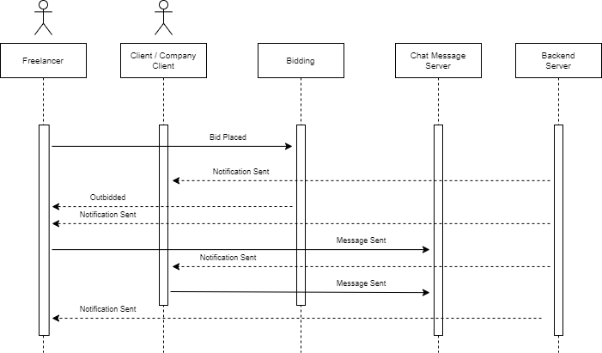

**1.10 Chat Message System**

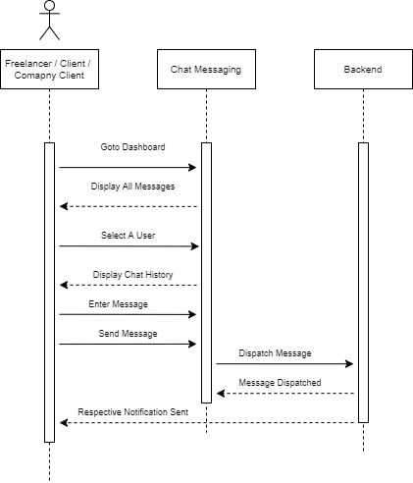

**1.11 Rating / Feedback System**

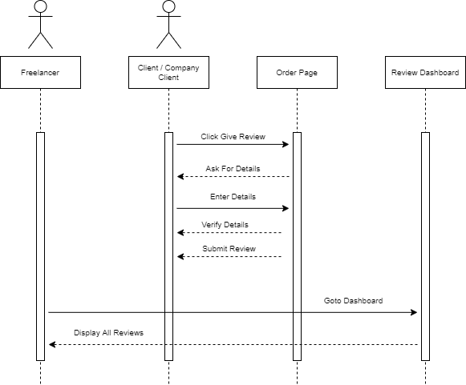

**1.12 Personalized Testing System**

